

‘News from the plot’

Green FiNGERS’ Allotment project March & April 2015

Date:

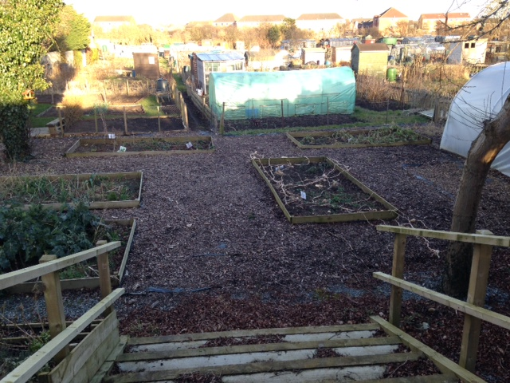 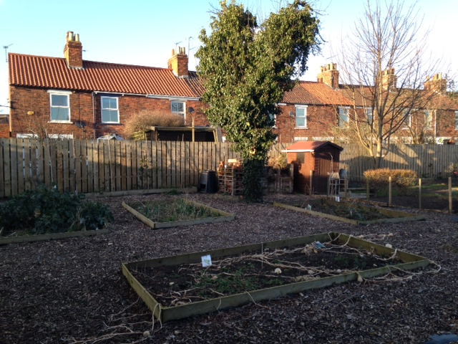

What have we been up to -

It’s been a busy couple of months with lots of ideas, planning & work underway

At FiND 2 we’ve been;

* Planting seeds
* Planning gardening activities with students
* Shopping & sourcing gardening tools & items

At the allotment we’ve been;

* Planting on & planning the areas with potatoes, strawberries herbs etc
* Visiting regularly for watering & maintaining the areas
* Harvesting broccoli & rhubarb – inc sampling !

We were delighted to receive a kind donation of £ 250 from ERYC, which kick-started the project by being spent on much needed tools, equipment, planters & compost !

We have also received donations from a local garden centre, FiND ‘lets cook’ fundraising activity, a sponsorship donation & pots from Bishop Burton college

This has been spent so far on;

Garden storage seats, extra tools, plants & more compost !

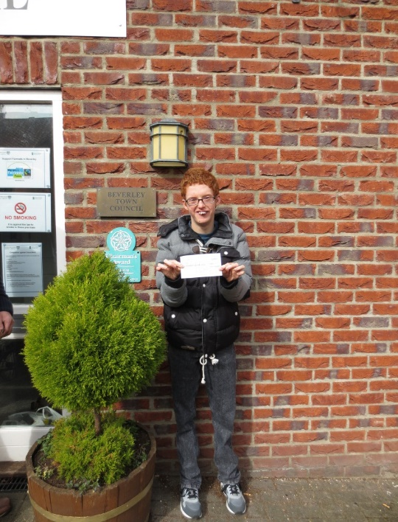

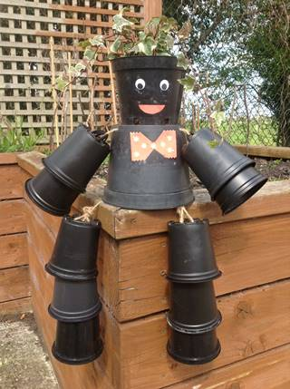

In addition to the many kind donations, we’ve been busy selling plants locally & have introduced for sale our very own ‘Mr Potters’ !

Available now for just £ 4 – with hanging baskets available soon . . .

What’s next . . .

Over the next 2 months we have plans for;

* Cookery groups using allotment produce
* Lots more planting on with tomatoes, carrots, sprouts etc
* Filling & selling hanging baskets – with home grown plants
* Making & selling plant & vegetable boxes – with home grown plants

 